Make your own starfish!

You will need:
- Card
- Orange paint
- Cheerios cereal
- Glitter
- PVA/runny glue

Method:
- Cut out the star shape from card
- Paint Orange.
- Cover the star in glue.
- Attach cheerios and glitter
- Cover cheerios in more PVA glitter – over the top as it will dry clear and cause the cheerios to stick better!
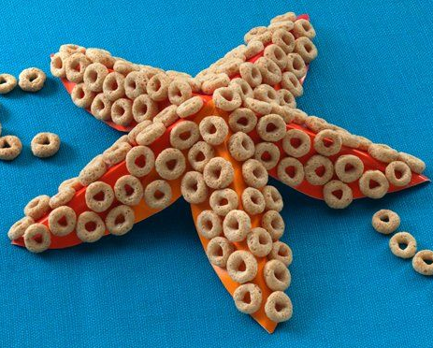
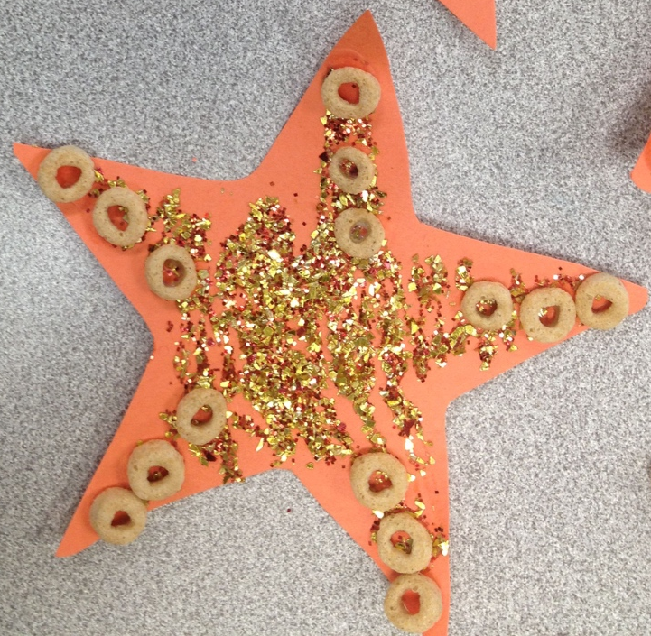
- Use the starfish in the story and have a sneaky taste of the cheerios too!



