Make your own fidgety fish!
- Cut out the fish template below.
- Use finger paints to decorate your fish in whatever colours you would like!
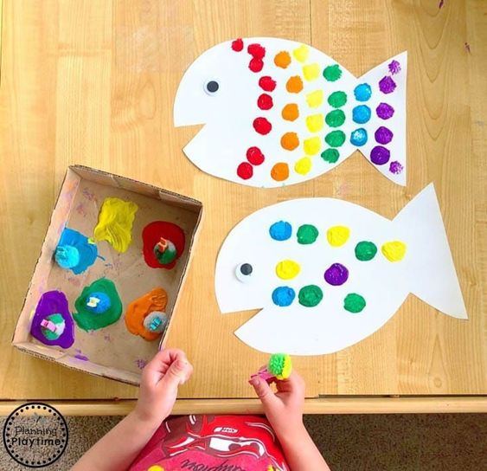
- Use Sellotape to attach the fish either to string to dangle or on a straw to wiggle when telling the story!



